**“Brief Description of how you tested your structures”**

**Queue:**

The testing process was very simple really. I would use the *qwerty* testing method. I would enter q <hit enter> w <hit enter> etc and so on until qwerty had been entered. Then I would enter a period . <hit enter>. This would then print out to me the results. I would expect a perfect result of q w e r t y spelled back to me in order. In addition, I tried with more than one letter on a line and it will choose the first letter.

Queue test 1

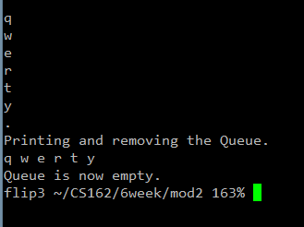

Queue test 2

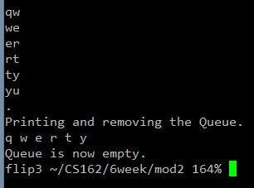

**Stack**

For stack, the process was the same. IE I would use the *qwerty* testing method again. On the stack, I would expect a perfect result of y t r e w q spelled back to me in backwards order. Like before, I tried with more than one letter on a line and it will choose the first letter like in test 2.

Stack Test 1

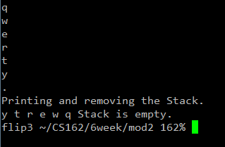

Stack Test 2

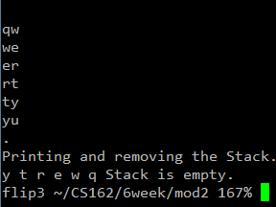

On both Stack and Queue, I knew I had done it correct if the results came back in perfect expected order.